Aviel Resnick

11.6

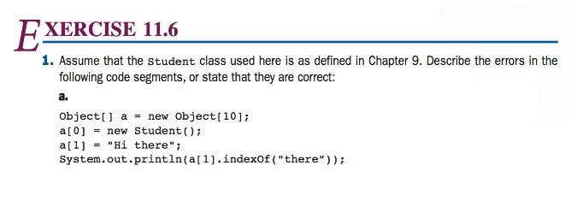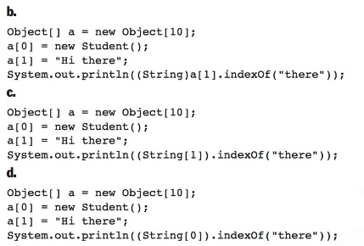

1. Syntax Error: a has to be cast to a string first.
2. Syntax Error: Missing parentheses around (String)a[1]
3. Errors throughout, but the main one is that the current code assumes an array called String, which is not possible.
4. The student object cannot be cast as a string.

11.10

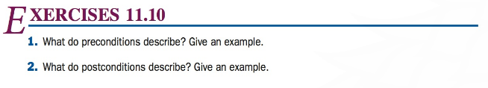

1. Preconditions describe conditions that need to be true before code is executed, for example an input value has to be a positive int / double for a square root function.
2. Postconditions are conditions which are expected to be true, after a section of code has completed, for example the circumference of a circle is PI \* Diameter

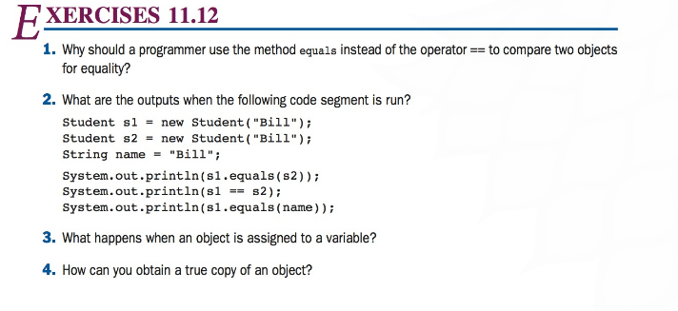

1. == is used to check for the same object, where is .equals is used to compare the values of two (possibly different) objects.
2. True (Same Value), False (Different Objects), False (Student vs String)
3. The variable servers as the reference or pointer of the object.
4. You can use a constructor to create a “true” copy of an object using the .clone method.